Name: Muhammad Abubakr

Roll No:25K-0503

Class & Section: BCS-1K

***PF LAB TASK# 5(4):***

***TASK#1:***

Program:

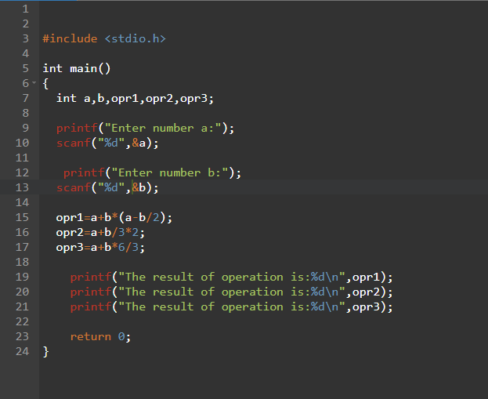

Output:

***TASK#2:***

Program:

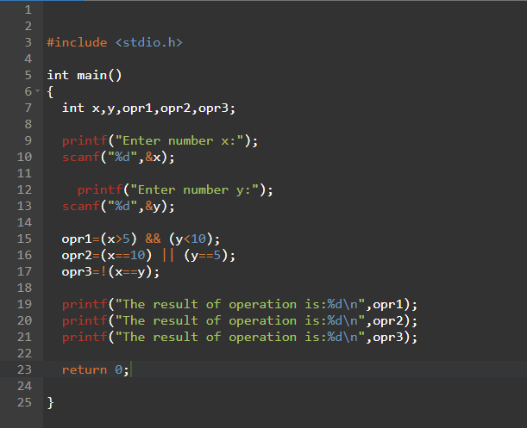

Output:

***TASK#3:***

Program:

Output:

***TASK#4:***

Program:

Output:

